L2-W2-DBS301-select-range-order

*STEP 1: rename the file to L2-your id name*

*STEP 2: Put the SQL and the results after each question below*

*STEP 3: Submit on Blackboard.*

1 Display the employee_id, last name and salary of employees earning in the range of $8000 to $15,000. Sort the output by top salaries first and then by last name.

SELECT EMPLOYEE_ID, LAST_NAME, SALARY

FROM EMPLOYEES

WHERE SALARY BETWEEN 8000 AND 15000

ORDER BY SALARY DESC, LAST_NAME DESC;

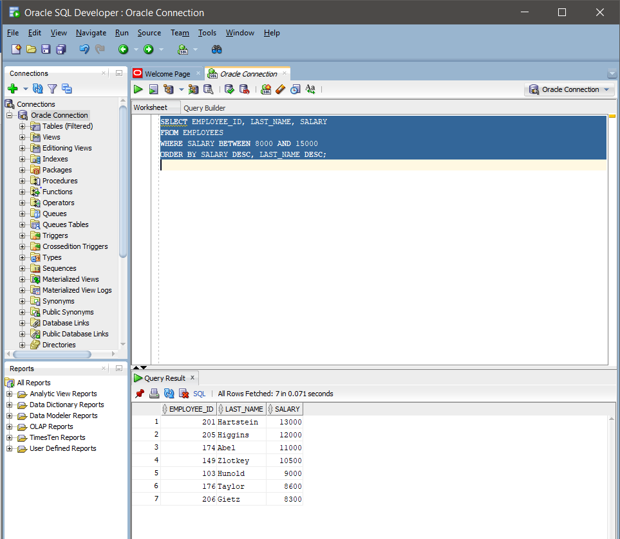

2 Modify previous query (#1) so that additional condition is to display only if they work as Programmers or Sales Representatives. Use same sorting as before.

SELECT EMPLOYEE_ID, LAST_NAME, SALARY

FROM EMPLOYEES

WHERE (SALARY >= 8000 AND SALARY <= 15000) AND (JOB_ID = 'IT_PROG' OR JOB_ID = 'SA_REP')

ORDER BY SALARY DESC, LAST_NAME ASC;

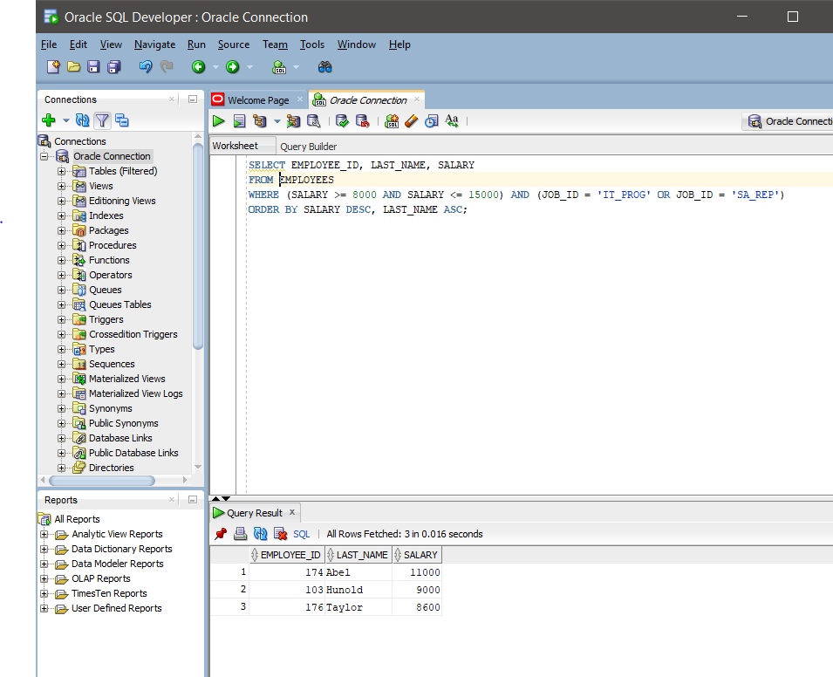

3 The Human Resources department wants to find high salary and low salary employees. Modify previous query (#2) so that it displays the same job titles but for people who earn outside the given salary range from question 1. Use same sorting as before.

SELECT EMPLOYEE_ID, LAST_NAME, SALARY

FROM EMPLOYEES

WHERE (SALARY <= 8000 AND SALARY >= 15000) AND (JOB_ID = 'IT_PROG' OR JOB_ID = 'SA_REP')

ORDER BY SALARY DESC, LAST_NAME ASC;

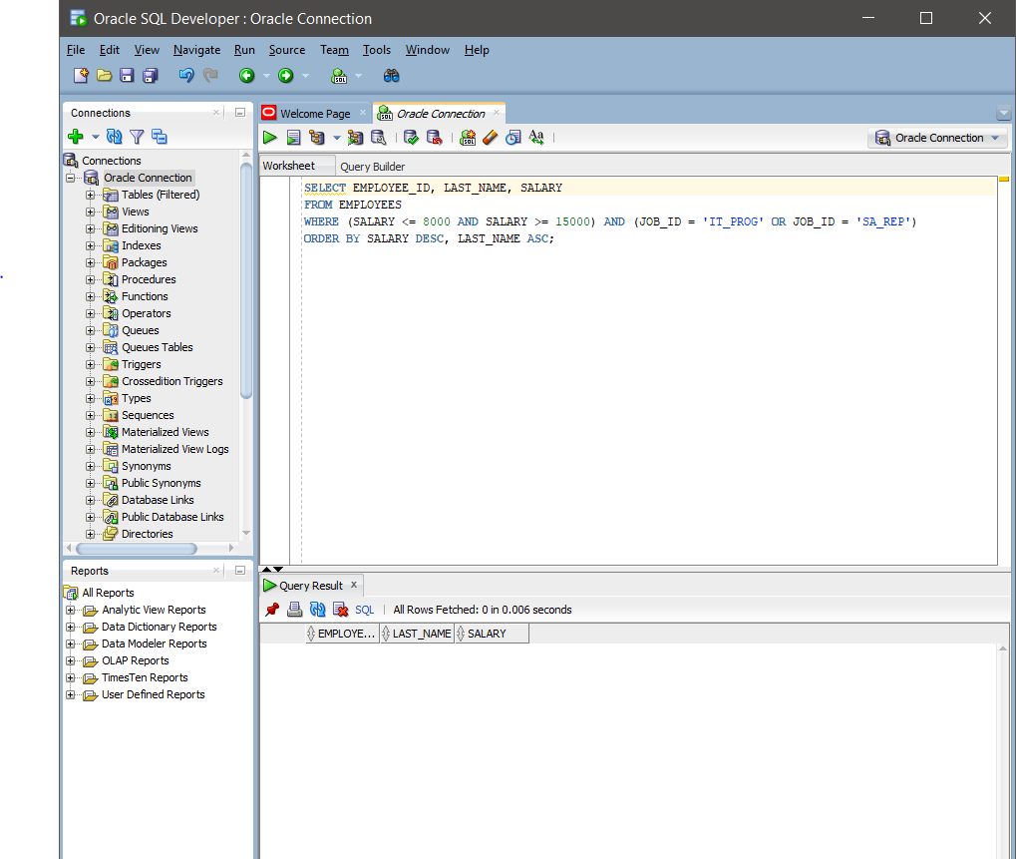

4 The company needs a list of long term employees, in order to give them a thankyou dinner. Display the last name, job_id and salary of employees hired before 1998. List the most recently hired employees first.

SELECT LAST_NAME, JOB_ID, SALARY

FROM EMPLOYEES

WHERE HIRE_DATE < TO_DATE ('1998-01-01', 'yyyy-mm-dd')

ORDER BY HIRE_DATE DESC;

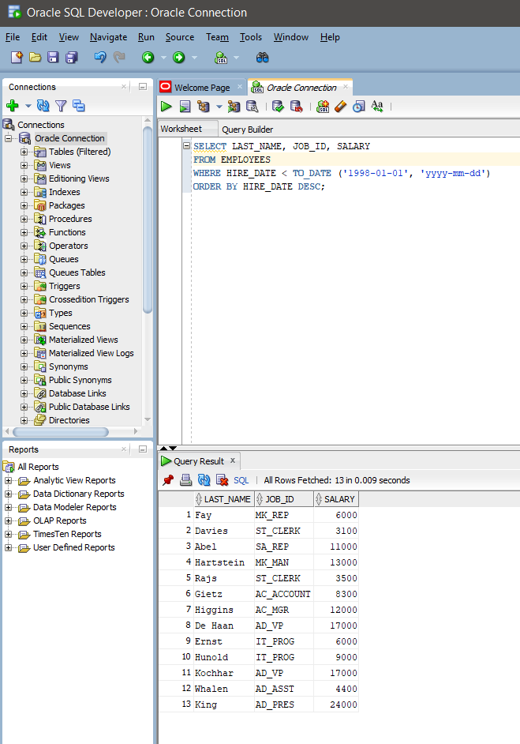

5 Modify previous query (#4) so that it displays only employees earning more than $10,000. List the output by job title alphabetically and then by highest paid employees.

SELECT LAST_NAME, JOB_ID, SALARY

FROM EMPLOYEES

WHERE HIRE_DATE < TO DATE (‘01-01-1998’ , ‘DD-MM-YYYY’) AND SALARY > 10000

ORDER BY JOB_ID, SALARY DESC;

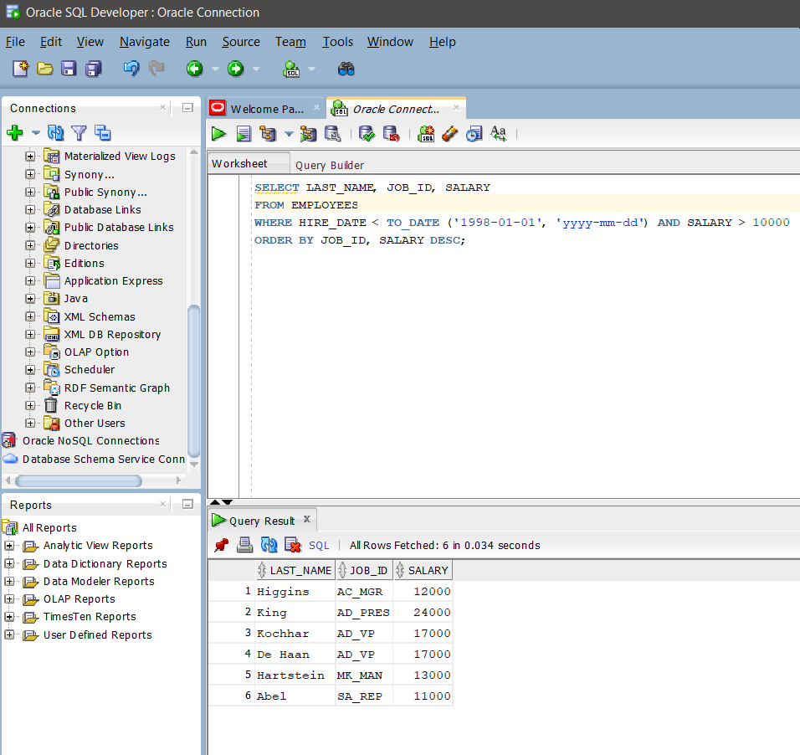

6 Display the job titles and full names of employees whose first name contains an ‘e’ or ‘E’ anywhere. The output should look like:

Job Title Full name

--------------------------------------

AD_VP Neena Kochhar

… more rows

SELECT JOB_ID AS "Job Title", FIRST_NAME || ' ' || LAST_NAME AS "Full name"

FROM EMPLOYEES

WHERE FIRST_NAME LIKE '%e%' OR FIRST_NAME LIKE '%E%';

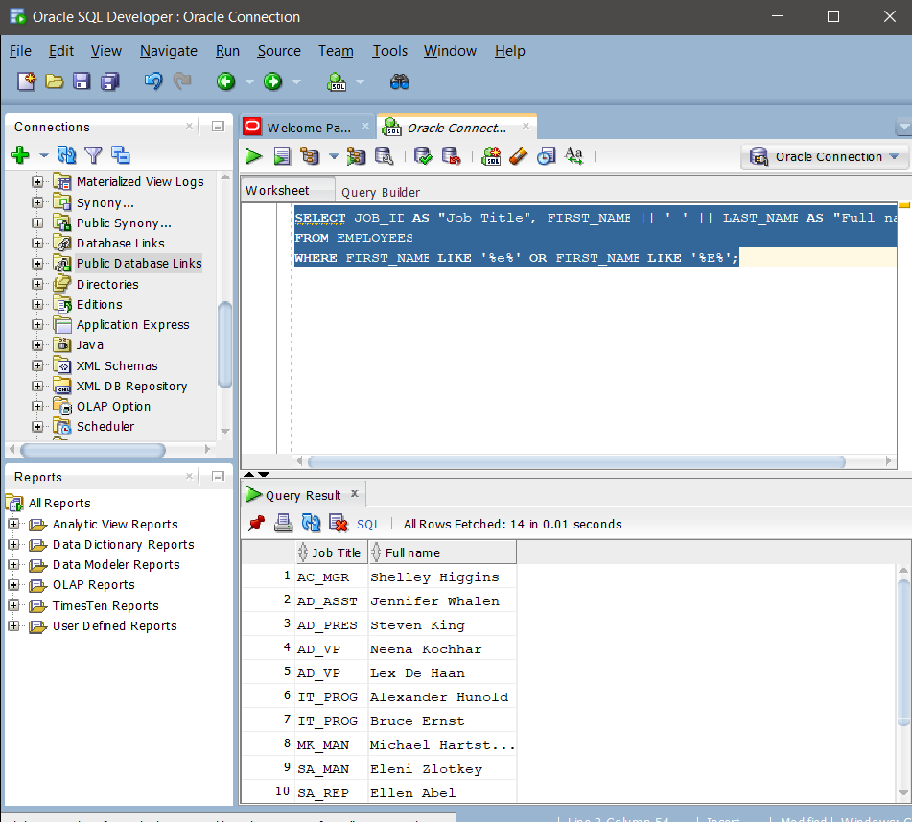

7 Create a report to display last name, salary, and commission percentage for all employees that earn a commission.

SELECT LAST_NAME, SALARY, COMMISSION_PCT

FROM EMPLOYEES

WHERE COMMISSION_PCT IS NOT NULL;

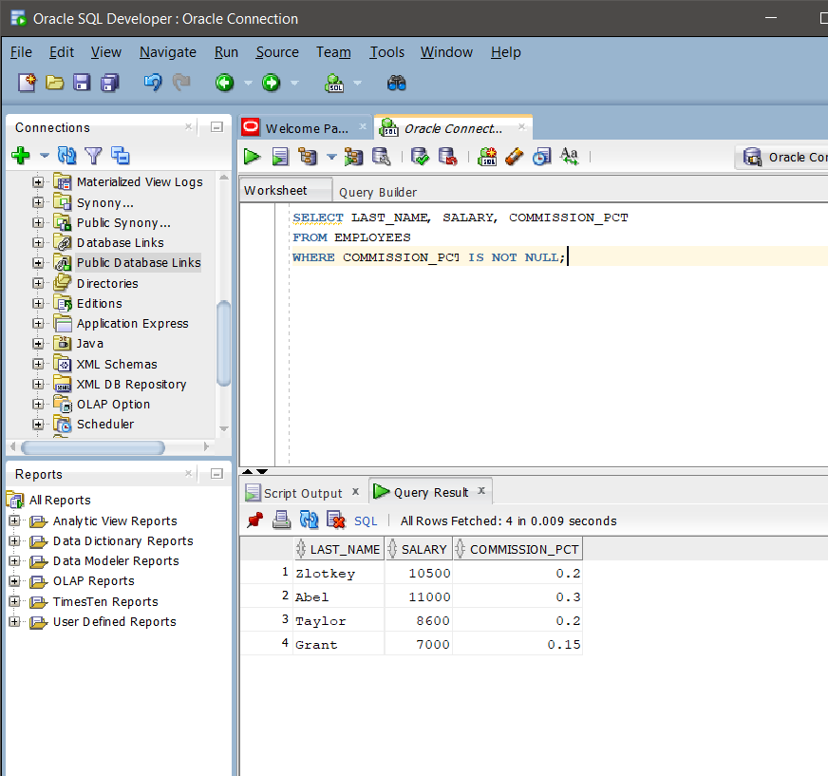

8 Do the same as question 7, but put the report in order of descending salaries.

SELECT LAST_NAME, SALARY, COMMISION_PCT

FROM EMPLOYEES

WHERE COMMISION_PCT IS NOT NULL

ORDER BY SALARY DESC;

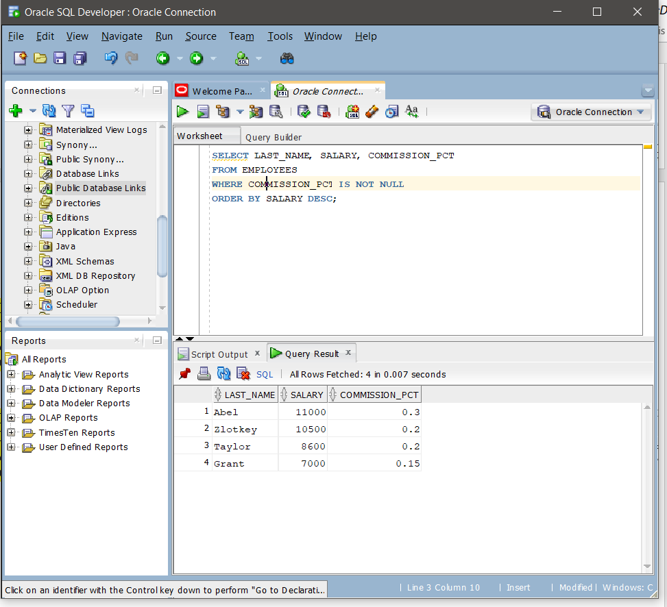

9 Do the same as 8, but use a numeric value instead of a column name to do the sorting.

SELECT LAST_NAME, SALARY, COMMISION_PCT

FROM EMPLOYEES

WHERE COMMISION_PCT IS NOT NULL

ORDER BY 2 DESC;

